Photo Album, Selections
Sandra (Sandy) Lach Arlinghaus
William Edward Arlinghaus with his maternal grandfather, Donald F. Lach (Bernadotte Schmitt Professor of History, University of Chicago), at the U-505 submarine, captured German U-boat parked outside the East Wing of the Museum of Science and Industry near 59th Street and Lakeshore Drive, across from 57th Street Beach, where it landed (as observed directly by William’s mother, Sandy—who was swimming in Lake Michigan when it arrived and was forced out of the water by the beach lifeguards).
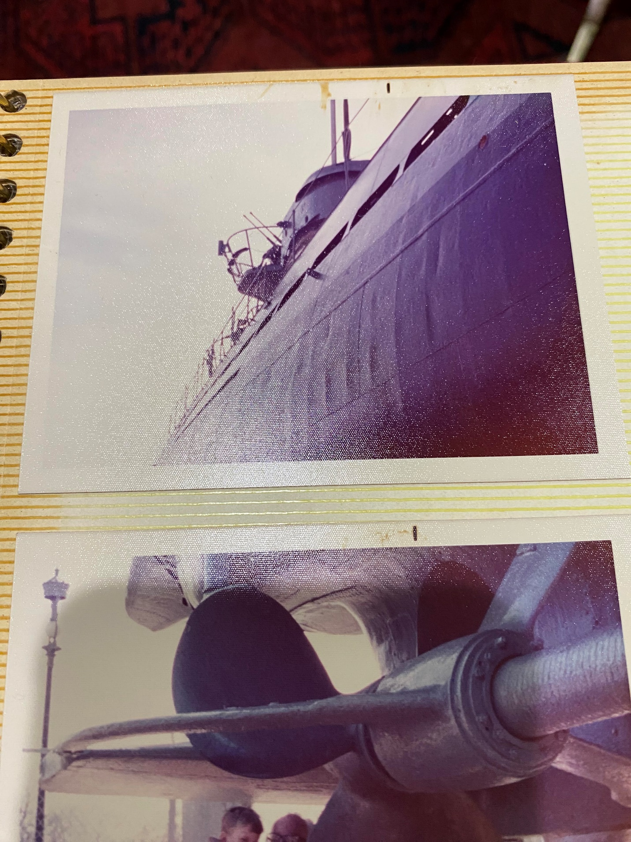
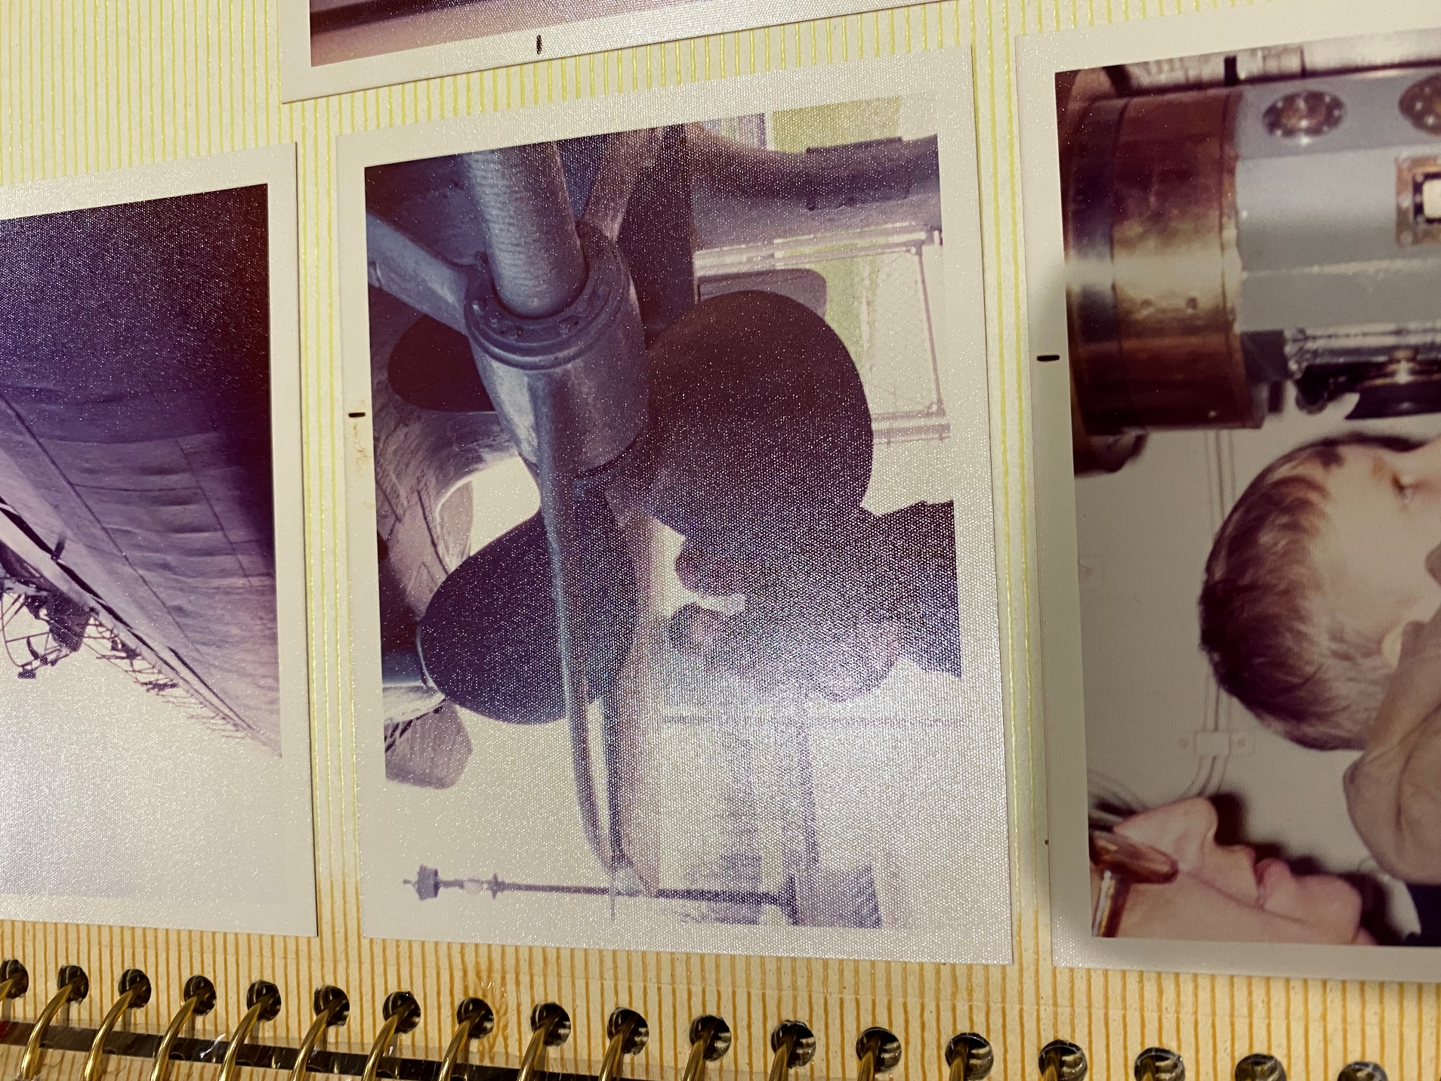
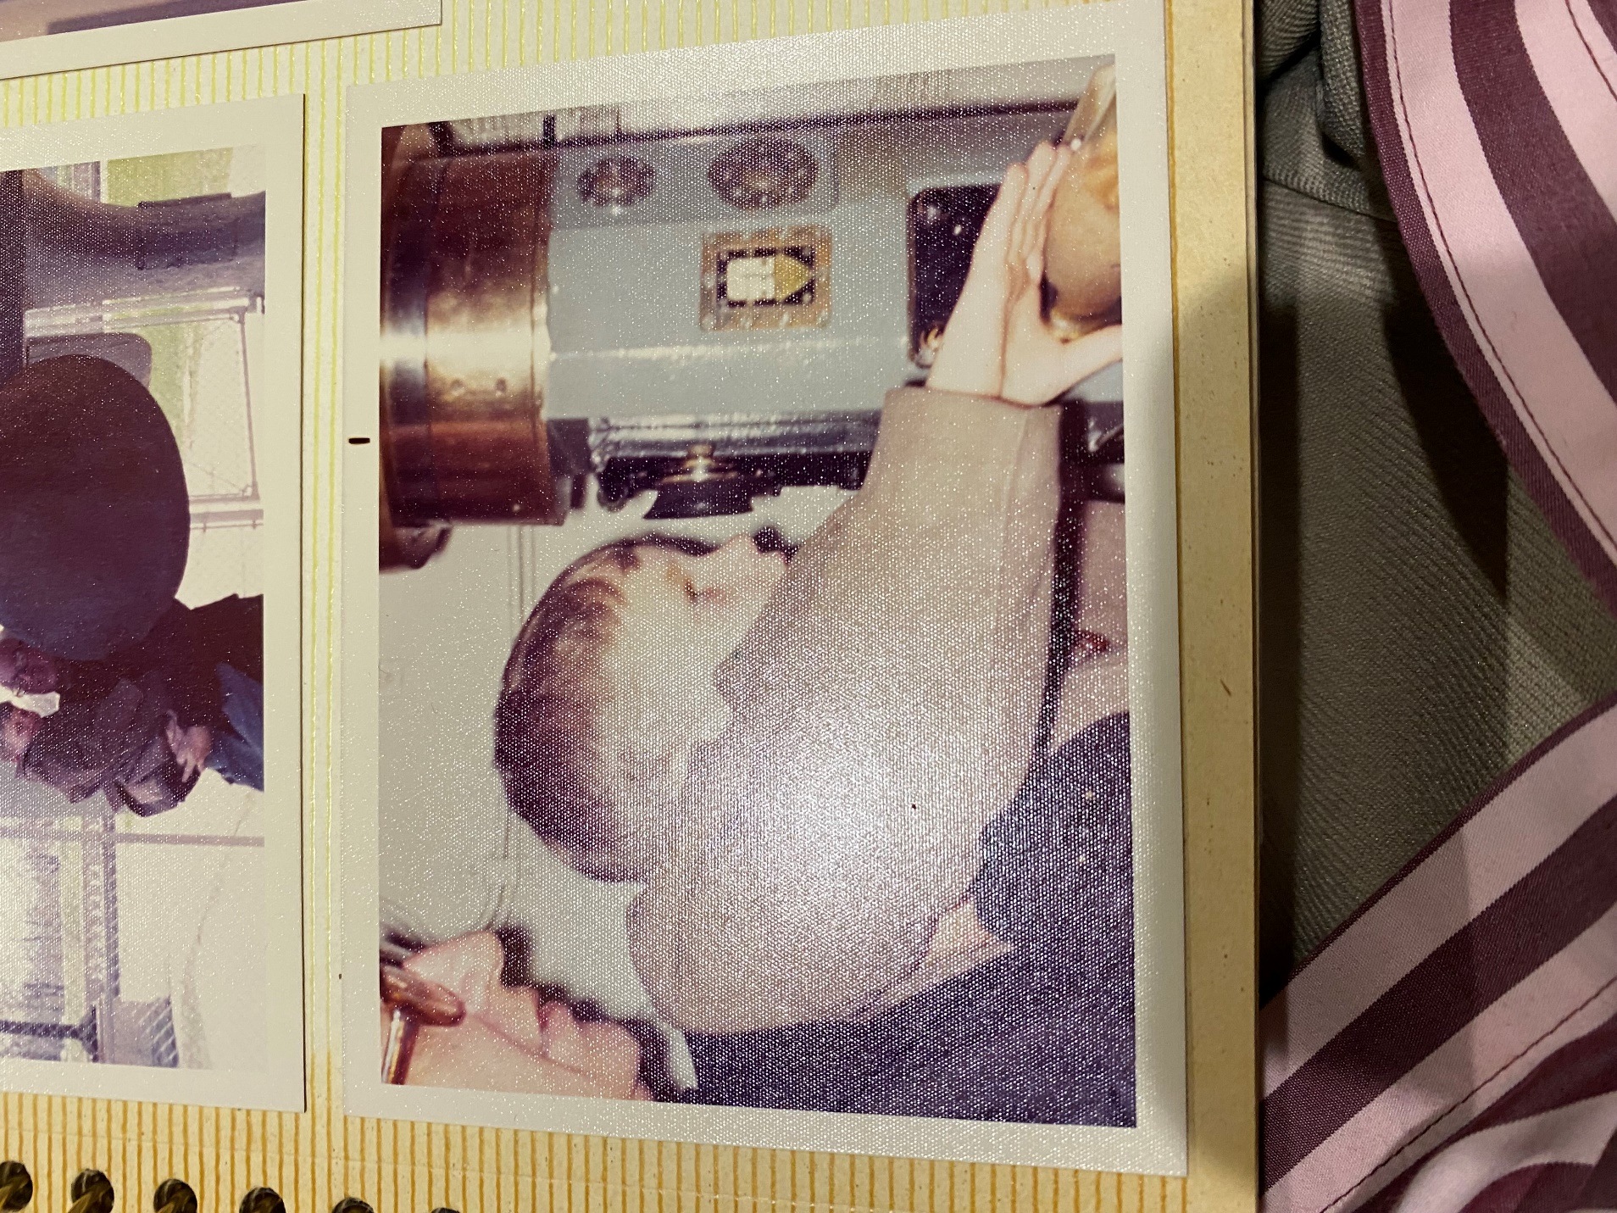
Grandfather and Grandson, similarly attired. What were they talking about? Clothing? Probably not. More likely, a history lesson of some sort in which Donald was regaling William with fascinating, and true, stories from the past.
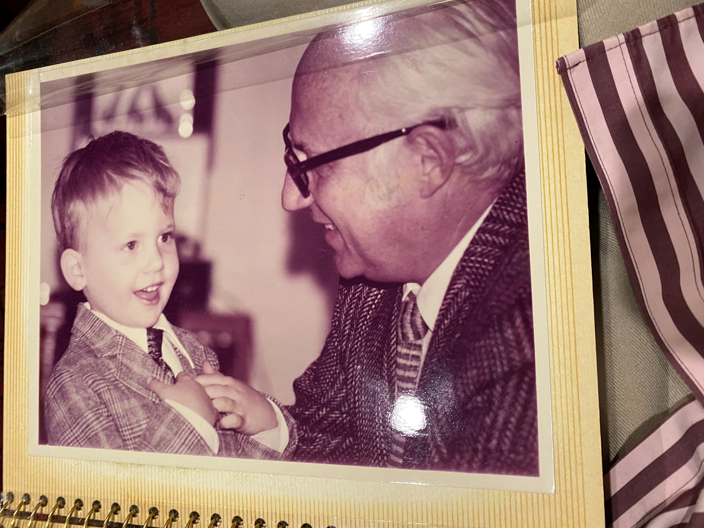

Elsewhere within the East Wing, at a much earlier time, Sandy receives instructions from her mother (Alma Lach, Grande Diplome Le Cordon Bleu, Paris, 1956) on how to use a knife, while a number of Sandy’s friends from the University of Chicago Laboratory Schools look on. Kitchen set was in the East Wing of the Museum of Science and Industry from which Alma televised one of the earliest children’s cooking shows, called “Let’s Cook”.
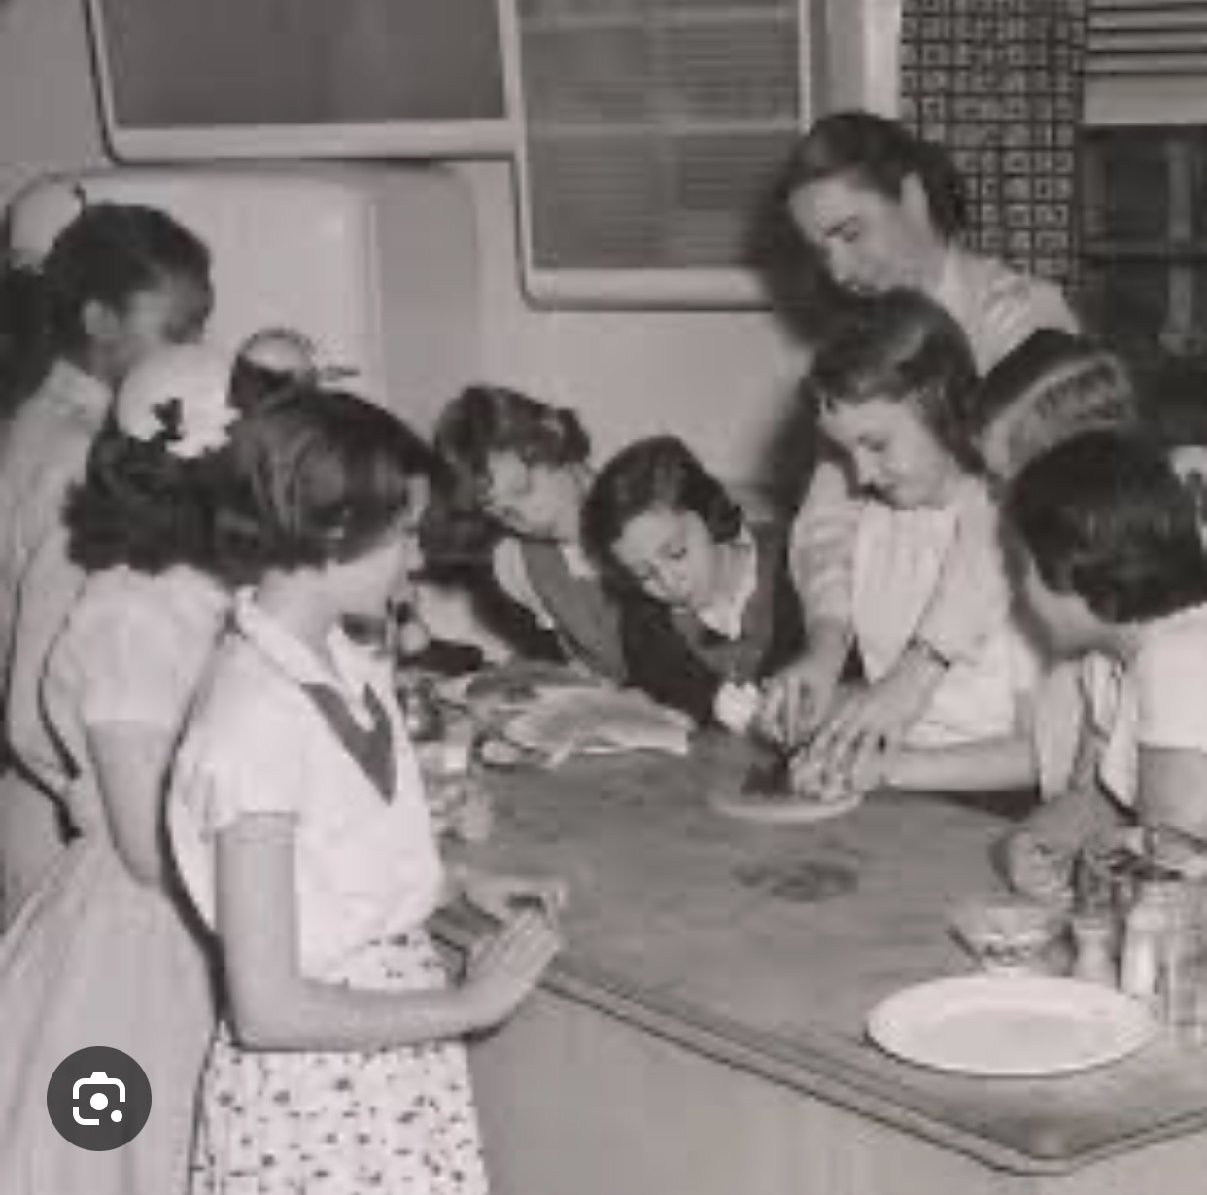
Alma Lach, standing behind Sandy Lach [Arlinghaus]. Friends to Sandy’s right are Nancy Foss and (Mary) Molly Perkins (daughter of John Forbes Perkins, U of C Department of Physiology). To Sandy’s left, are an unidentified girl, and Janet Friedman [Martel] (daughter of Rose and Milton Friedman, U of C Department of Economics). Across the counter from Janet is (Barbara) Lynn Fussler (daughter of Herman Fussler, U of C Library Director) and to Lynn’s left is Kay Hodes. To Kay’s left is Margaret Rosezarian Harris. Sandy remembers Margaret giving compelling mini-recitals, of Mozart and more, in Miss Carter’s second grade Lab School music classroom.

