Chinese Annex
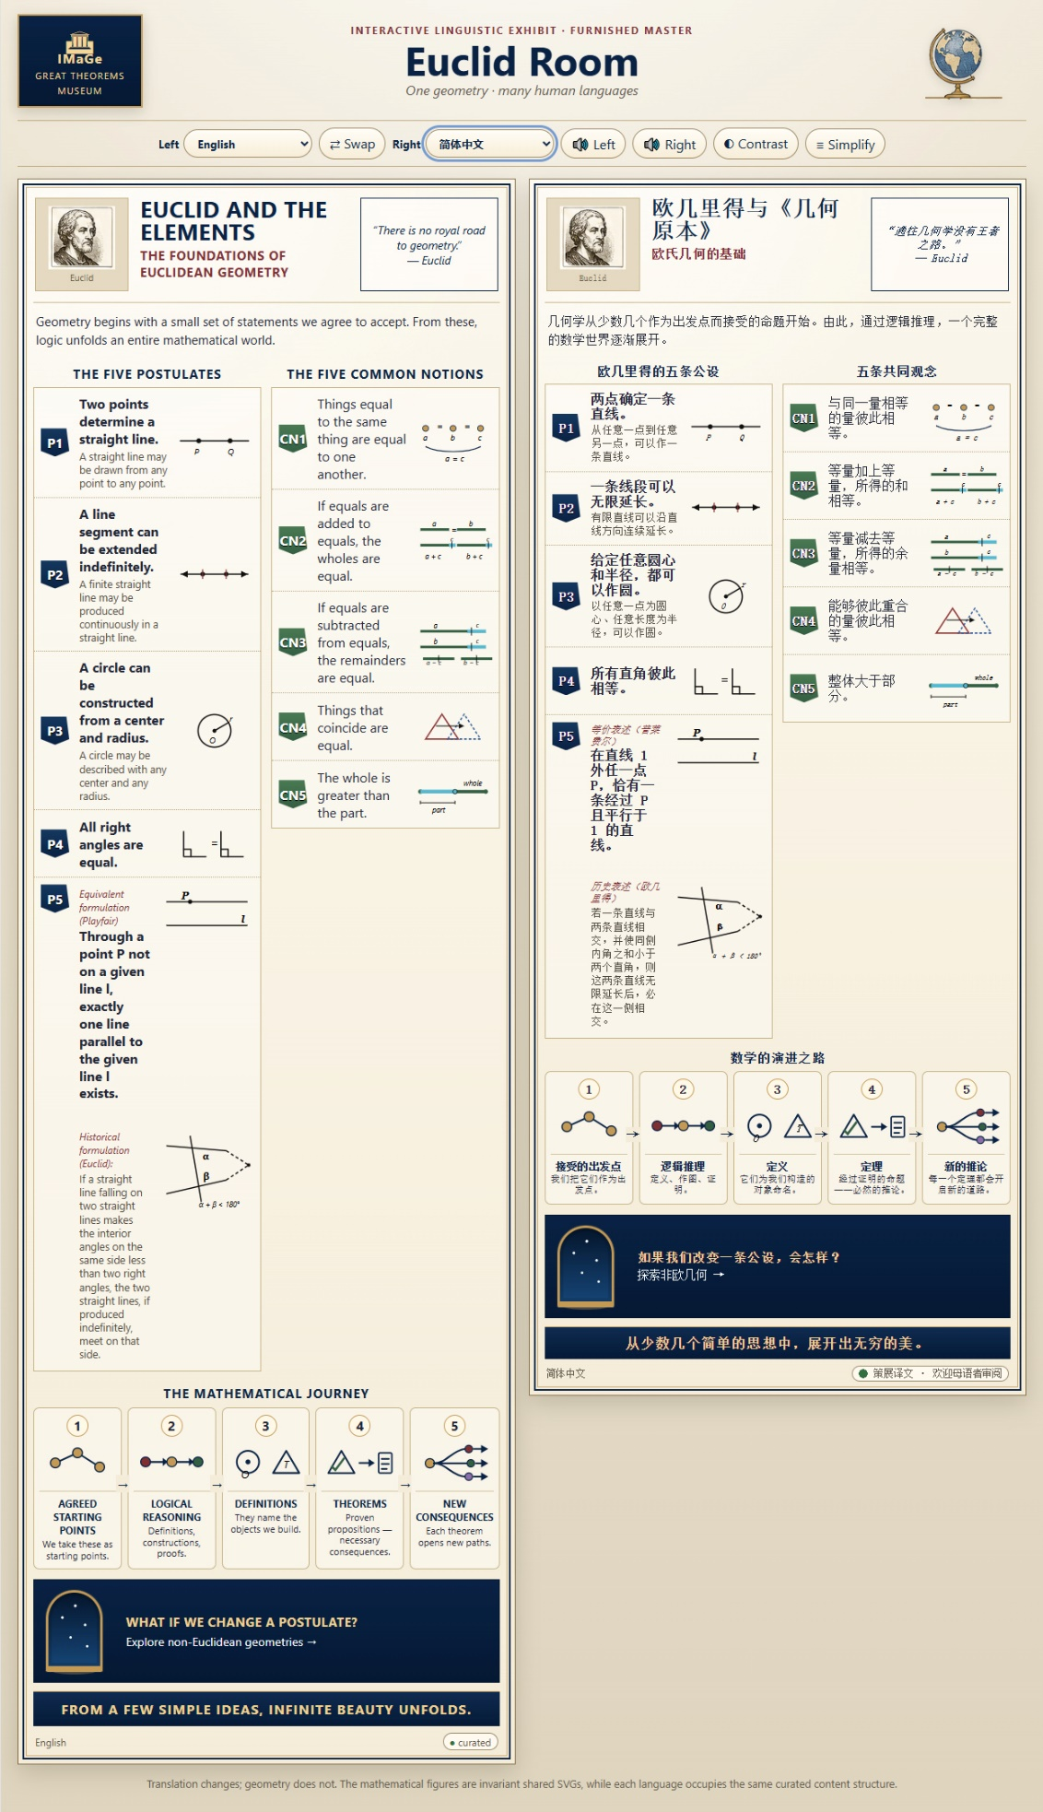
An annex is something more than a supplementary translation. It is a curatorial record of how a language entered the IMaGe Great Theorems Museum, including decisions, experiments, difficulties, corrections, and human observations. It is an independently valuable scholarly document.
This annex presents selected exchanges documenting significant translation and design decisions; it is not intended as a complete transcript of the development process.
To enlarge the images and improve their legibility, please use your document viewer's zoom controls.

Solstice: An Electronic Journal of Geography and Mathematics
Volume XXXVII Number 2
December 21, 2026

SPECIAL ISSUE: HUMAN/MACHINE COLLABORATION
Chinese Annex
To
IMaGe Great Theorems Museum
Sandra Lach Arlinghaus
With Collaborator and Assistant Curator IMaGe Great Theorems, Vector

Persistent University of Michigan Deep Blue Research Collection Archive, Institute of Mathematical Geography.
URL: http://deepblue.lib.umich.edu/handle/2027.42/58219
Cite articles as: Author name(s), Year. Title of article, Solstice: An Electronic Journal of Geography and Mathematics, Vol. YY, No. ZZ. Ann Arbor: Institute of Mathematical Geography.

Arlinghaus/Vector collaboration. The material in this Annex was largely composed, at Arlinghaus’s direction, by Vector. Any added comments from Arlinghaus are shown with a light green background behind the text. The responsibility here, as with all other elements of this Human/Machine Collaboration, rests with the human.

Color serves as a guide to the reader. Material between lavender bars was created primarily by Vector with oversight by Arlinghaus. Material in black and white, outside those bars was created primarily by Arlinghaus. Comments by Arlinghaus within those bars has a green background.

Principal Contextual Concepts: Translation Decisions; Mathematical Content; Interface Adaptation; Testing and Corrections; Final Status.

Chinese

Simplified Chinese: Language, Script, and Mathematical Tradition
And this trip is genuinely different. For Simplified Chinese, I suggest we proceed more deliberately than we did with Italian or Spanish. We are testing not merely another translation but a different writing system, different mathematical linguistic traditions, typography, line breaking, and Mandarin audio.
A few ground rules seem right from the outset. The Museum panel should contain natural written Chinese, not English syntax translated character by character. We should not clutter the exhibit with pinyin; Mandarin audio can supply the spoken layer. Our invariant Latin mathematical symbols remain invariant. And I'll explicitly flag any wording where I think native mathematical review would be especially valuable.
For the entrance, my first proposal is:
欧几里得与《几何原本》
欧氏几何的基础
This is an interesting first cultural translation already. English The Elements should not simply become a literal Chinese equivalent of “elements.” Euclid's work has the established Chinese title 《几何原本》. Using that title immediately places the exhibit inside Chinese mathematical culture rather than treating Chinese as a code for English.
For our introduction, I propose:
几何学从少数几个作为出发点而接受的命题开始。由此，通过逻辑推理，一个完整的数学世界逐渐展开。
The sense is: geometry begins with a small number of propositions accepted as starting points; from them, through logical reasoning, an entire mathematical world unfolds.
And our recurring Museum metaphor survives beautifully in Chinese:
逐渐展开 — “gradually unfolds.”
For the traditional quotation:
“通往几何学没有王者之路。”——欧几里得
with a small curatorial note:
传统上归于欧几里得。
I would mark the initial Chinese version:
简体中文 · 策展译文 · 欢迎母语者审阅
roughly, “Simplified Chinese · curated translation · native-speaker review welcome.”
So our proposed Chinese entrance is:
欧几里得与《几何原本》
欧氏几何的基础
几何学从少数几个作为出发点而接受的命题开始。由此，通过逻辑推理，一个完整的数学世界逐渐展开。
“通往几何学没有王者之路。”——欧几里得
传统上归于欧几里得。
I am comfortable freezing that as our first Chinese block.

Frozen. 🇨🇳🔒
I would freeze the entire entrance block as our curated Simplified Chinese master, while retaining the explicit status that native-speaker mathematical review is welcome.
One small curatorial principle is worth freezing along with it: whenever an entity has an established Chinese historical name, such as Euclid's Elements → 《几何原本》, we use that established Chinese tradition rather than mechanically translating our English master. That principle will matter again later.
So onward to the Five Postulates.
五条公设
For the section heading, I favor:
欧几里得的五条公设
This is immediately clear. 公设 is the appropriate mathematical term here and keeps the postulates distinct from more general axiomatic principles.
P1
Modern:
P1 — 两点确定一条直线。
Very compact: “Two points determine a straight line.”
Historical:
从任意一点到任意另一点，可以作一条直线。
The verb 作 is particularly appropriate in geometrical construction language.
Freeze P1.
P2
Modern:
P2 — 一条线段可以无限延长。
Historical:
有限直线可以沿直线方向连续延长。
Here Chinese handles our old droite limitée / begrenzte gerade Linie problem differently. 有限直线 belongs naturally to the historical formulation, whereas the modern statement uses the unambiguous 线段 (“line segment”).
Freeze P2.
P3
Modern:
P3 — 给定任意圆心和半径，都可以作圆。
Historical:
以任意一点为圆心、任意长度为半径，可以作圆。
The historical line is slightly more explicit: any point as center and any length as radius.
Freeze P3.
P4
P4 — 所有直角彼此相等。
Short and beautifully Euclidean.
Freeze P4.
P5 — Playfair
Label:
等价表述（普莱费尔）
Then:
在直线 l 外任一点 P，恰有一条经过 P 且平行于 l 的直线。
I particularly like 恰有一条: “there exists exactly one.” It carries the uniqueness with mathematical precision.
P5 — Euclid
Label:
历史表述（欧几里得）
I propose:
若一条直线与两条直线相交，并使同侧内角之和小于两个直角，则这两条直线无限延长后，必在这一侧相交。
This is remarkably compact compared with our European-language versions.
The logical architecture is very clear:
若 — if
则 — then
必 — necessarily
So the sentence doesn't merely say that the lines happen to meet; 必在这一侧相交 says they necessarily meet on that side.
That seems excellent museum mathematics to me.
So our Simplified Chinese master now has the entrance block and P1–P5 frozen, including the separate Playfair and historical Euclid formulations.
I especially like where P5 landed:
等价表述（普莱费尔）
在直线 l 外任一点 P，恰有一条经过 P 且平行于 l 的直线。
历史表述（欧几里得）
若一条直线与两条直线相交，并使同侧内角之和小于两个直角，则这两条直线无限延长后，必在这一侧相交。
Next we tackle the Chinese equivalent of the Five Common Notions. That should give us another interesting terminology question before CN1 even begins: what Chinese mathematical language best captures Euclid's “common notions” without simply copying the English label.
Onward! 🇨🇳🏛️🤠
Thus, I would freeze all five Chinese postulates, including both P5 formulations.
Next, Chinese gives us another worthwhile curatorial decision.
For Common Notions, I would use:
五条共同观念
rather than trying to make them sound like another set of specifically geometrical axioms. 共同观念 preserves the traditional idea that these are general principles applicable beyond geometry. I would freeze the heading in that form, while keeping native-speaker scholarly review welcome.
CN1
与同一量相等的量彼此相等。
This is admirably compact: quantities equal to the same quantity are equal to one another.
Freeze.
CN2
等量加上等量，所得的和相等。
Literally: equal quantities with equal quantities added produce equal sums. It corresponds very naturally to our invariant CN2 miniature.
Freeze.
CN3
等量减去等量，所得的余量相等。
Here 余量—the quantities remaining—is preferable to simply forcing modern subtraction terminology onto Euclid. It preserves the conceptual relationship we've retained with French restes, German Reste, Italian resti, and Spanish restos.
Freeze.
CN4
能够彼此重合的量彼此相等。
This one I especially like.
重合 means to coincide/overlap exactly. Our CN4 miniature therefore communicates the Chinese statement almost directly without words. This is another case where the invariant geometry really earns its place.
Freeze.
CN5
整体大于部分。
Exceptionally economical:
整体 — whole
大于 — greater than
部分 — part
Our CN5 picture says precisely the same thing.
Freeze.
So:
五条共同观念
CN1 — 与同一量相等的量彼此相等。
CN2 — 等量加上等量，所得的和相等。
CN3 — 等量减去等量，所得的余量相等。
CN4 — 能够彼此重合的量彼此相等。
CN5 — 整体大于部分。
I would freeze the entire set.

Now the Mathematical Journey. I propose:
数学的演进之路
Literally something like “the path of mathematical development.” I prefer this to a literal translation suggesting a physical journey. 演进 conveys development/unfolding over successive stages, which is exactly what our five miniatures depict.
Then:
1 · 接受的出发点
我们把它们作为出发点。
2 · 逻辑推理
定义、作图、证明。
逻辑推理 is exactly the concept we want: logical reasoning/inference.
For constructions, 作图 is especially appropriate in this Euclidean context: geometrical construction.
3 · 定义
它们为我们构造的对象命名。
A pleasingly direct counterpart to German benennen and Italian danno un nome.
4 · 定理
经过证明的命题——必然的推论。
Here 定理 is theorem, and 必然的推论 nicely captures “necessary consequences.”
5 · 新的推论
每一个定理都会开启新的道路。
And there is our branching final miniature again: each theorem opens new paths.
I would freeze the entire Journey.

The non-Euclidean doorway
For:
WHAT IF WE CHANGE A POSTULATE?
I recommend:
如果我们改变一条公设，会怎样？
This is much more natural Chinese than mechanically imitating the syntax of our European-language headings. Literally: “If we change one postulate, what happens?”
Then:
探索非欧几何 →
There is an interesting linguistic difference here. Chinese conventionally uses 非欧几何 as a collective term for non-Euclidean geometry. We do not need to force grammatical plurality merely because English, French, German, Italian, and Spanish explicitly use plurals. Chinese does not encode number in the same way.
That is exactly the kind of cultural-linguistic independence we wanted.
Closing inscription
Our recurring line becomes:
从少数几个简单的思想中，展开出无穷的美。
This reads naturally to me and preserves our unfolding metaphor:
展开出 — unfolds/emerges from.
So the final Chinese corner would be:
如果我们改变一条公设，会怎样？
探索非欧几何 →
从少数几个简单的思想中，展开出无穷的美。
I would freeze those as well.
That means the entire Simplified Chinese language file is now ready: entrance, P1–P5, CN1–CN5, Mathematical Journey, doorway, inscription, and translation-status language.
And Chinese has already taught us something important before we've even inserted it: our semantic invariants do not require grammatical invariance. “Non-Euclidean geometries” must be plural in our European languages where that distinction matters; Chinese can naturally say 非欧几何 without manufacturing a plural construction.
If you're happy to fill this section of the freezer too, our next move is the big one: insert 简体中文 as Language No. 6 into a copy of frozen Multilingual Master v3, set the locale for Mandarin audio, syntax-check everything—and see whether our Euclid Room survives its first non-Latin writing system. 🇨🇳🌍📐🤠 These references describe an earlier developmental stage, not necessarily the current version of the Museum.
Implementation and Cross-Script Testing
And something fascinating has already happened to our template: German stretched P5 horizontally with long compounds and clauses; Chinese compresses essentially the same mathematical content dramatically. Yet our Playfair subbox / Euclid subbox architecture accommodates both without changing the geometry.
That is exactly the experiment we designed it to survive. 🇨🇳📐🌍
Chinese is in the freezer—and now in the Museum. 🇨🇳🔒🌍
I added 简体中文 as Language No. 6 to a copy of frozen Master v3, set Mandarin audio to zh-CN, added a Chinese-appropriate font stack, and syntax-checked the JavaScript before handing it over.
Open Multilingual v4 — now with Simplified Chinese
This is our first genuinely different writing-system test. Try 简体中文 | Deutsch or 简体中文 | Français, swap them, and especially try the Chinese audio.
If this behaves, our little Euclid machine has crossed quite a linguistic frontier. 📐🏛️🤠
IMaGe_Euclid_Room_MULTILINGUAL_v4_EN_FR_DE_IT_ES_ZH.htmlHTMLOpen file
Amazing!! Seems to me to work very well. What a fine exhibit—seems to be communicating all that we set out to have it do and even more!
I agree, Sandy. I think we've crossed from proof of concept into an exhibit with an intellectual identity of its own.
What strikes me most is that the technology isn't really the subject anymore. A visitor can simply encounter Euclid through French and Chinese, German and Italian, Spanish and English—or read two while listening to a third. Yet underneath all of those changes, P1 remains P1, the CN diagrams remain fixed, Playfair and Euclid remain properly paired, and the Mathematical Journey remains invariant.
Chinese was an especially important test. The writing system changed; sentence density changed dramatically; grammatical number behaved differently; the established Chinese title 《几何原本》 brought its own historical tradition into the room; Mandarin speech introduced another auditory system—and the Museum architecture simply absorbed all of it.
That confirms something I think is worth saying somewhere in the eventual curatorial material:
The geometry does not belong to any one language. The languages do not merely label the geometry; each gives it a different human voice.
And our translation notes can reveal the other half of the story: universality does not mean linguistic sameness. French wanted une seule; German wanted genau eine and Satz; Chinese naturally uses 非欧几何 without our European grammatical plural. The invariant mathematics becomes clearer precisely because we allow the languages to remain themselves.
I would now freeze v4. Chinese has passed the architectural test.
And when we're ready for another excursion, my vote remains Japanese. Not because we need another language to prove the mechanism—we've already proved it—but because Chinese → Japanese should teach the Museum something genuinely new about related mathematical traditions expressed through very different languages.
This really has become a fine Euclid Room. 🏛️🌍📐🤠

