Spanish Annex
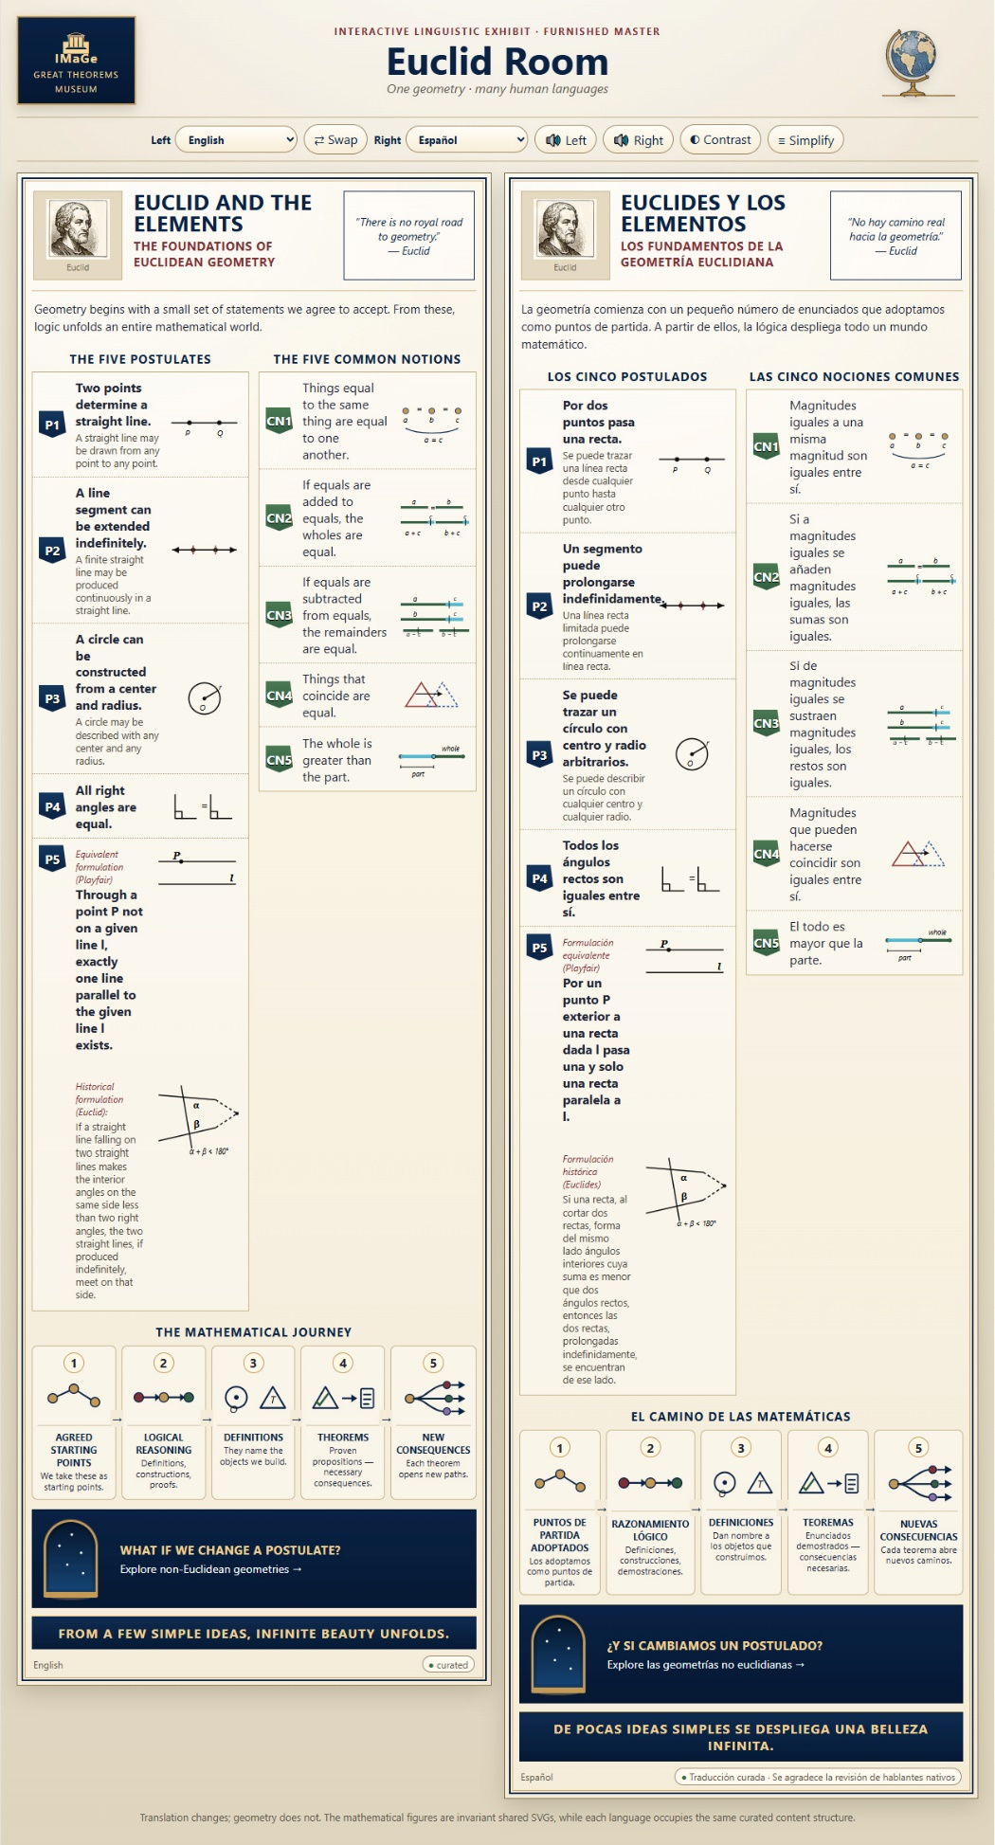
An annex is something more than a supplementary translation. It is a curatorial record of how a language entered the IMaGe Great Theorems Museum, including decisions, experiments, difficulties, corrections, and human observations. It is an independently valuable scholarly document.
This annex presents selected exchanges documenting significant translation and design decisions; it is not intended as a complete transcript of the development process.
To enlarge the images and improve their legibility, please use your document viewer's zoom controls.

Solstice: An Electronic Journal of Geography and Mathematics
Volume XXXVII Number 2
December 21, 2026

SPECIAL ISSUE: HUMAN/MACHINE COLLABORATION
Spanish Annex
To
IMaGe Great Theorems Museum
Sandra Lach Arlinghaus
With Collaborator and Assistant Curator IMaGe Great Theorems, Vector

Persistent University of Michigan Deep Blue Research Collection Archive, Institute of Mathematical Geography.
URL: http://deepblue.lib.umich.edu/handle/2027.42/58219
Cite articles as: Author name(s), Year. Title of article, Solstice: An Electronic Journal of Geography and Mathematics, Vol. YY, No. ZZ. Ann Arbor: Institute of Mathematical Geography.

Arlinghaus/Vector collaboration. The material in this Annex was largely composed, at Arlinghaus’s direction, by Vector. Any added comments from Arlinghaus are shown with a light green background behind the text. The responsibility here, as with all other elements of this Human/Machine Collaboration, rests with the human.

Color serves as a guide to the reader. Material between lavender bars was created primarily by Vector with oversight by Arlinghaus. Material in black and white, outside those bars was created primarily by Arlinghaus. Comments by Arlinghaus within those bars has a green background.

Principal Contextual Concepts: Translation Decisions; Mathematical Content; Interface Adaptation; Testing and Corrections; Final Status.

Spanish

I would begin the entrance with:
EUCLIDES Y LOS ELEMENTOS
LOS FUNDAMENTOS DE LA GEOMETRÍA EUCLIDIANA
La geometría comienza con un pequeño número de enunciados que adoptamos como puntos de partida. A partir de ellos, la lógica despliega todo un mundo matemático.
I particularly like adoptamos como puntos de partida: it preserves our careful distinction between assumptions and established truths.
And despliega gives Spanish its version of our wonderful recurring thread:
unfolds → déploie → entfaltet → si dispiega → despliega
For the traditional quotation:
«No hay camino real hacia la geometría.» — Euclides
Tradicionalmente atribuido a Euclides.
I would tentatively freeze that entrance block and move directly into:
LOS CINCO POSTULADOS
Then P1–P5, with our familiar two-level modern/historical treatment and the separate Playfair/Euclid structure already waiting for Spanish.
So yes, Vector is back at the multilingual curator's desk. ¡Adelante! 🤠
Sounds good. Please start filling the freezer! Go for it!

Absolutely. Let's start freezing Spanish. 🇪🇸❄️
For LOS CINCO POSTULADOS, I would use the same modern/historical distinction we established in the other languages.
P1
P1 — Por dos puntos pasa una recta.
Se puede trazar una línea recta desde cualquier punto hasta cualquier otro punto.
The first line is wonderfully natural mathematical Spanish. Recta is the contemporary mathematical object; línea recta gives the historical line its slightly older constructional voice.
Freeze P1.
P2
P2 — Un segmento puede prolongarse indefinidamente.
Una línea recta limitada puede prolongarse continuamente en línea recta.
Here we meet our multilingual old friend:
French: droite limitée
German: begrenzte gerade Linie
Italian: linea retta limitata
Spanish: línea recta limitada
I would emphatically avoid recta finita for the same reason we rejected its equivalents elsewhere.
Freeze P2.
P3
P3 — Se puede trazar un círculo con centro y radio arbitrarios.
Se puede describir un círculo con cualquier centro y cualquier radio.
Again, trazar provides immediate contemporary meaning while describir un círculo preserves some of the traditional constructional vocabulary.
Freeze P3.
P4
P4 — Todos los ángulos rectos son iguales entre sí.
Simple, idiomatic, and historically faithful.
Freeze P4.

P5 — Playfair
Label:
Formulación equivalente (Playfair)
Statement:
Por un punto P exterior a una recta dada l pasa una y solo una recta paralela a l.
I like una y solo una very much here. It is idiomatic mathematical Spanish and expresses uniqueness explicitly without sounding translated.
P5 — Euclid
Label:
Formulación histórica (Euclides)
I propose:
Si una recta, al cortar dos rectas, forma del mismo lado ángulos interiores cuya suma es menor que dos ángulos rectos, entonces las dos rectas, prolongadas indefinidamente, se encuentran de ese lado.
And Spanish joins German and Italian in benefiting from the explicit conditional hinge:
Si … entonces …
I would keep entonces. The historical P5 sentence carries considerable information before reaching its consequence, and entonces makes the logical structure immediately audible.
I also prefer al cortar dos rectas to a forced historical calque corresponding to “falling upon two lines.” As with Italian, the historical mathematics itself already distinguishes Euclid's formulation from Playfair's; the Spanish needn't be artificially archaic.
So P5 freezes as:
Formulación equivalente (Playfair)
Por un punto P exterior a una recta dada l pasa una y solo una recta paralela a l.
Formulación histórica (Euclides)
Si una recta, al cortar dos rectas, forma del mismo lado ángulos interiores cuya suma es menor que dos ángulos rectos, entonces las dos rectas, prolongadas indefinidamente, se encuentran de ese lado.
That gives us P1–P5 frozen.

LAS CINCO NOCIONES COMUNES
Here, as in Italian, I would retain the traditional terminology:
LAS CINCO NOCIONES COMUNES
It is perfectly intelligible Spanish and has the historical connection we want.
CN1
Magnitudes iguales a una misma magnitud son iguales entre sí.
CN2
Si a magnitudes iguales se añaden magnitudes iguales, las sumas son iguales.
CN3
Si de magnitudes iguales se sustraen magnitudes iguales, los restos son iguales.
I would keep restos, preserving the Euclidean conception just as we retained restes / Reste / resti.
CN4
Magnitudes que pueden hacerse coincidir son iguales entre sí.
This one is especially nice. Hacerse coincidir maps beautifully onto our invariant CN4 miniature.
CN5
El todo es mayor que la parte.
Nothing needs embellishment.
I would freeze all five.
EL CAMINO DE LAS MATEMÁTICAS
Here I prefer:
EL CAMINO DE LAS MATEMÁTICAS
rather than El viaje matemático. Camino has the conceptual-development quality we want without becoming overly literary.
The five stages:
PUNTOS DE PARTIDA ADOPTADOS
Los adoptamos como puntos de partida.
RAZONAMIENTO LÓGICO
Definiciones, construcciones, demostraciones.
DEFINICIONES
Dan nombre a los objetos que construimos.
That last phrase is particularly natural Spanish—very close conceptually to Italian danno un nome.
TEOREMAS
Enunciados demostrados — consecuencias necesarias.
NUEVAS CONSECUENCIAS
Cada teorema abre nuevos caminos.
And there our branching miniature earns its keep again: abre nuevos caminos.
Freeze the Journey.
Doorway
I propose:
¿Y SI CAMBIAMOS UN POSTULADO?
There is another possibility, ¿Y si cambiáramos un postulado?, analogous to our Italian cambiassimo. But I prefer cambiamos here. In contemporary Spanish it is wonderfully immediate and inviting without sounding casual.
Then:
Explore las geometrías no euclidianas →
Plural firmly retained.
Closing inscription
DE UNAS POCAS IDEAS SIMPLES SE DESPLIEGA UNA BELLEZA INFINITA.
This is good, but I hear a trace of English in unas pocas. I would improve it to:
DE POCAS IDEAS SIMPLES SE DESPLIEGA UNA BELLEZA INFINITA.
Much cleaner. It sounds like an inscription rather than a translation.
And it closes our Spanish despliega echo from the introduction. This annex explains why unas pocas was rejected, but we emphasize that despliega echoes the entrance's la lógica despliega todo un mundo matemático.
So I would freeze the entire Spanish master text as:
Entrance ✓
P1–P5 ✓
CN1–CN5 ✓
Mathematical Journey ✓
Doorway ✓
Closing inscription ✓
For metadata:
Español
Traducción curada · Se agradece la revisión de hablantes nativos
Translation Status and Initial Installation
I would initially leave the regional variant as Español internacional, rather than claiming either Spain or Latin America as normative. If your Latin-American Spanish collaborator later recommends changes, we can determine whether they improve international Spanish generally or reveal a genuine regional distinction.
And if you approve this set, the next operation is purely mechanical: add es to a copy of Multilingual Master v2, syntax-check it before handing it to you, and see whether you can display Español | Deutsch while listening to Italiano—or whatever linguistic combination strikes your fancy. And, please note that this is an account of the earlier developmental stage, not a claim about the current multilingual master.
Spanish is in—and I syntax-checked the working file before handing it over this time.

